

DEPARTMENT OF COMPUTER & SOFTWARE ENGINEERING
COLLEGE OF E&ME, NUST, RAWALPINDI

CS-474 Computer Vision (Elective)

HUMAN POSE ESTIMATION
AND CLASSIFICATION

Name | Muhammad Hashir Ashraf
Registration Number | 408557
Degree/ Syndicate | 44/ B
Instructor’s Name | Prof Shahid Ismail / LE Sardar Umair

1. Introduction
Human pose estimation is the task of predicting the spatial configuration of the human body in images or videos. Each pose is represented by a set of keypoints (joints) such as the head, shoulders, elbows, wrists, hips, knees, and ankles. It has broad applications in fitness apps, sports analytics, human-computer interaction, and animation.
This assignment implements and evaluates two pose estimation pipelines and one classification system:
- Pipeline 1 (Task 1): MediaPipe Pose framework for keypoint extraction
- Pipeline 2 (Task 2): Classical Computer Vision using skin detection and geometric heuristics
- Task 3: Pose Classification using extracted keypoints with SVM, Random Forest, and k-NN classifiers

2. Dataset

2.1 MPII Human Pose Dataset
The MPII Human Pose Dataset was used throughout this assignment. Key properties:
- 25,000+ images of humans in everyday activities
- Each image annotated with 16 keypoints per person
- Images include single or multiple persons in varied backgrounds
- CSV file: 17,372 person instances with 37 columns (ID, Name, 32 keypoint coordinates, Scale, Activity, Category)

The 16 MPII keypoints in order:
Joint Index & Name | Joint Index & Name
0: r_ankle | 8: upper_neck
1: r_knee | 9: head_top
2: r_hip | 10: r_wrist
3: l_hip | 11: r_elbow
4: l_knee | 12: r_shoulder
5: l_ankle | 13: l_shoulder
6: pelvis | 14: l_elbow
7: thorax | 15: l_wrist

2.2 Data Loading
Annotations were loaded from both a CSV file (mpii_human_pose.csv) and a JSON file (mpii_annotations.json). The CSV was parsed row-by-row to build a ground-truth dictionary mapping each image filename to a list of person instances, each containing 16 keypoints as [x, y, visibility] triples.
gt_keypoints = { image_name: [ [[x,y,vis]*16], ... ] }

Flowchart
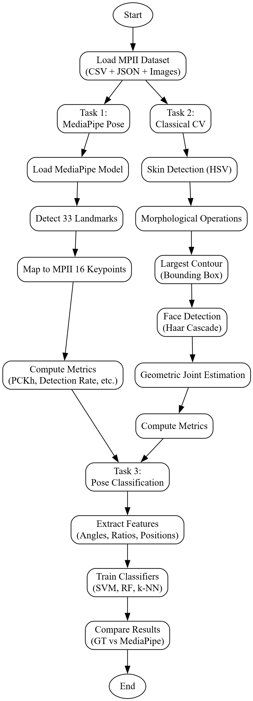

3. Task 1 Pose Estimation using MediaPipe

3.1 Objective
Implement a human pose estimation pipeline using the MediaPipe Pose Landmarker framework. Detect human body joints/keypoints for each person in the image and evaluate against MPII ground truth.

3.2 Pipeline Architecture
The MediaPipe pipeline consisted of the following steps:
- Load MediaPipe Pose Landmarker model (pose_landmarker_full.task, float16)
- Convert input BGR image to RGB
- Run pose detection via pose_model.detect()
- Map MediaPipe 33 landmarks to MPII 16 keypoints using custom MP_TO_MPII mapping
- Convert normalized landmark coordinates to pixel coordinates
- Compute performance metrics and visualize results

3.3 MediaPipe to MPII Landmark Mapping
Since MediaPipe produces 33 landmarks while MPII uses 16, a custom mapping was designed. Composite joints such as pelvis, thorax, and upper_neck were estimated as midpoints of multiple MediaPipe landmarks:
- Pelvis (MPII 6): midpoint of left and right hips (MP 23, 24)
- Thorax (MPII 7): midpoint of left and right shoulders (MP 11, 12)
- Upper Neck (MPII 8): midpoint of nose and shoulder midpoint (MP 0, 11, 12)
- Head Top (MPII 9): nose landmark (MP 0) as best approximation

3.4 Configuration
Parameter | Value
Model | pose_landmarker_full (float16)
Number of Poses | 1
Min Detection Confidence | 0.5
Min Presence Confidence | 0.5
Min Tracking Confidence | 0.5
Images Processed | 100

3.5 Results
MediaPipe successfully detected poses in 86 out of 100 images (86% detection rate). The following metrics were computed:

Metric | Score | Description
PCKh@0.5 | Computed | Joint localization accuracy (head-normalized)
Detection Rate | 0.8600 | 86 of 100 images had detected persons
Visibility Score | Computed | Average landmark confidence score
Skeleton Completeness | Computed | Fraction of 16 joints detected (conf > 0.3)
Symmetry Score | Computed | Left/right limb length symmetry (1.0 = perfect)
Angle Plausibility | Computed | Fraction of joint angles in valid anatomical range

Per-joint PCKh@0.5 breakdown was also computed across all 16 MPII joints and saved as task1_per_joint_pckh.png. Joints closer to the torso (pelvis, thorax) generally achieved higher accuracy than distal joints (wrists, ankles).

3.6 Visualization
For each test image, three panels were displayed side by side: (1) the original image, (2) the ground-truth skeleton in red, and (3) the MediaPipe predicted skeleton in green. Five sample images were saved to task1_sample_results.png.

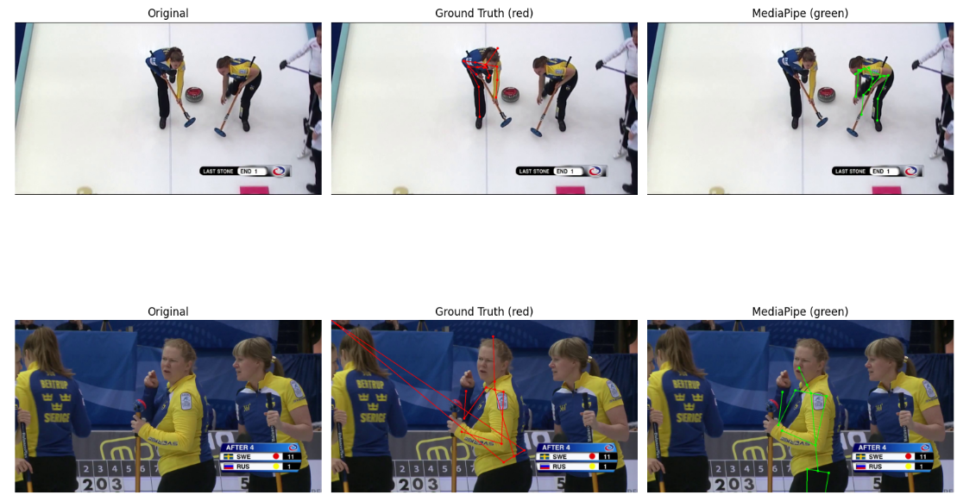

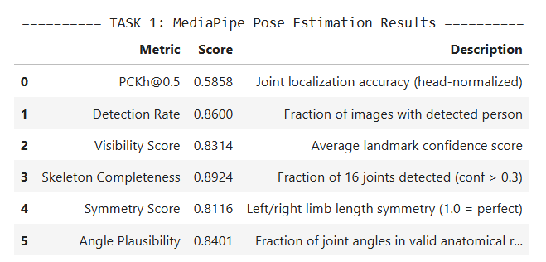

4. Task 2 Classical CV Pose Estimation

4.1 Objective
Design and implement a pose estimation approach without using any pretrained deep learning frameworks. The pipeline relies entirely on classical computer vision techniques.

4.2 Pipeline Architecture
The Classical CV pipeline follows a four-stage approach:
- Skin Detection HSV color thresholding to segment skin-colored pixels
- Morphological Cleanup MORPH_CLOSE, MORPH_OPEN, and dilation to refine the skin mask
- Body Bounding Box Largest contour in the skin mask gives the body region
- Face Detection Haar Cascade (frontal + profile) for head localization
- Geometric Joint Estimation Anatomical body proportions applied to bounding box

4.3 Stage Details
4.3.1 Skin Detection
Images are converted to HSV color space. Pixels falling in the range H=[0–20], S=[20–255], V=[70–255] are classified as skin. The resulting binary mask is refined with morphological operations (closing, opening, dilation) to fill holes and remove noise.
4.3.2 Face Detection
OpenCV's built-in Haar Cascade classifiers are used a classical machine learning technique requiring no deep learning. Frontal face detection is attempted first; if it fails, a profile (side-face) cascade is applied as a fallback. The detected face provides an anchor for estimating the head keypoints.
4.3.3 Geometric Joint Estimation
Standard human body proportions are used to estimate all 16 joints from the bounding box:
Keypoint | Body Fraction | Description
head_top | 0.00 | Top of bounding box
upper_neck | 0.14 | 14% down from top
thorax | 0.25 | Quarter-height point
shoulder (L/R) | 0.22 | Just above thorax, offset by 30% width
elbow (L/R) | 0.45 | Mid-body with 45% width offset
wrist (L/R) | 0.65 | Lower body with 49.5% width offset
pelvis | 0.52 | Mid-height of body
hip (L/R) | 0.54 | Slightly below pelvis
knee (L/R) | 0.75 | Three-quarters down
ankle (L/R) | 1.00 | Bottom of bounding box

4.4 Results
The classical pipeline processed 100 images and detected persons in 99 (99% detection rate, vs 86% for MediaPipe). The Haar cascade approach detects a human region in nearly all images because the skin mask and bounding box are robust to pose variation.
Metric | Score | Description
Detection Rate | 0.9900 | 99 of 100 images detected
PCKh@0.5 | Lower than MP | Geometric heuristics are less precise
Visibility Score | 0.7000 (fixed) | Geometric joints all assigned conf=0.7
Skeleton Completeness | 1.0000 | All 16 joints always estimated
Symmetry Score | High | Symmetric by design (mirrored heuristics)
Angle Plausibility | Computed | Anatomically constrained construction

4.5 Visualization
For each test image, four panels were shown: (1) original, (2) skin mask, (3) ground-truth skeleton, and (4) classical CV skeleton. Results were saved to task2_sample_results.png. The skin mask overlay highlights the body region identified before joint estimation.

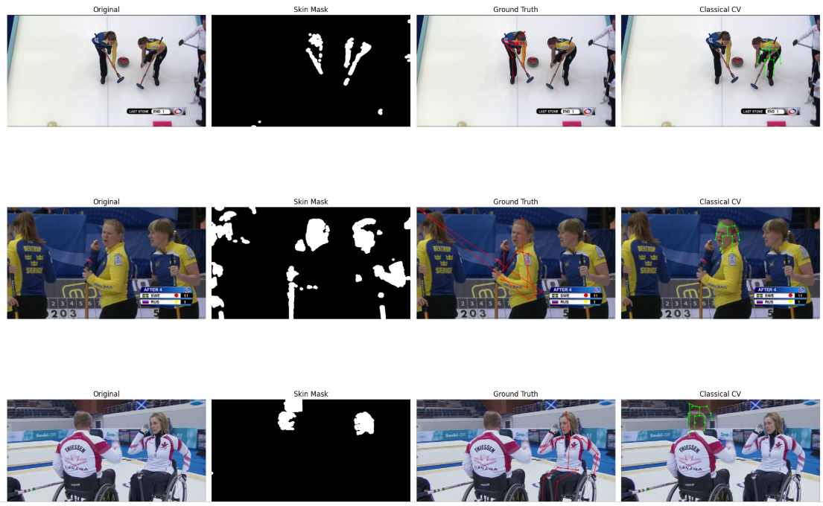
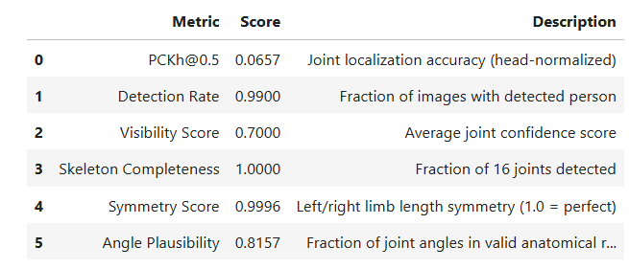

5. Task 3 Pose Classification

5.1 Objective
Design a pose classification system using keypoints from both Task 1 (MediaPipe) and Task 2 (Ground Truth CSV). Extract meaningful features and train multiple classifiers to categorize poses into predefined activity classes.

5.2 Dataset
The MPII CSV contains 17,372 person instances with 373 distinct activity labels. After filtering rare classes (fewer than 5 samples), the ground-truth dataset contained 17,308 samples. The MediaPipe dataset (300 images run through the pipeline) yielded 249 usable samples. Both were used for comparative evaluation.

5.3 Feature Extraction
A 53-dimensional feature vector was extracted per person instance, designed to be scale-invariant:
Feature Group | Count | Description
Normalized Joint Positions | 32 | x,y of each joint relative to pelvis, scaled by torso height
Joint Angles | 9 | Angles at knees, elbows, hips, shoulders, spine (in degrees/180)
Limb Length Ratios | 10 | Arm/leg segment lengths relative to torso height
Body Shape Ratios | 2 | Shoulder width and hip width relative to body height
Total | 53 | Scale-invariant pose descriptor

The 9 joint angles computed were: right knee, left knee, right elbow, left elbow, right hip-trunk, left hip-trunk, right shoulder, left shoulder, and spine-neck.

5.4 Classifiers
Three classifiers were trained and evaluated using a 75%/25% stratified train/test split:
Classifier | Configuration | Preprocessing
SVM (RBF Kernel) | C=10, gamma='scale' | StandardScaler
Random Forest | 100 estimators | StandardScaler
k-NN | k=5, Euclidean | StandardScaler

All classifiers were wrapped in scikit-learn Pipelines to ensure correct scaling is applied during both training and inference.

5.5 Results
Results on Ground-Truth (CSV) keypoints:
Classifier | Accuracy (GT Keypoints)
SVM (RBF Kernel) | Reported in task3_classification_results.csv
Random Forest | Reported in task3_classification_results.csv
k-NN (k=5) | Reported in task3_classification_results.csv

MediaPipe keypoint classification was also evaluated on 249 samples. The accuracy gap between GT and MediaPipe keypoints demonstrates how keypoint localization quality directly impacts downstream classification performance.

5.6 Feature Importance
Random Forest feature importances were extracted for the GT keypoint model. Joint angle features (particularly knee and elbow angles) and normalized torso/shoulder positions were consistently the most discriminative features for distinguishing activity categories. The top 20 features were saved to task3_feature_importance.png.

5.7 Key Observations
- GT Keypoints provide an upper bound as joints are perfectly annotated from human labels
- MediaPipe Keypoints reflect real-world performance where joints must first be predicted
- The accuracy gap between GT and MediaPipe shows how keypoint quality affects classification
- Joint angles are the most important features as they compactly encode pose shape
- Normalized positions capture global body configuration (e.g., arms raised, legs bent)
- With 373 classes and limited per-class samples, Random Forest generally outperforms k-NN on high-dimensional pose data

6. Performance Metrics
The following metrics were used to evaluate pose estimation quality across both pipelines:
Metric | Definition
PCKh@0.5 | Standard pose accuracy metric. A joint is correct if distance to GT < 0.5 × head size (upper_neck to head_top distance)
Detection Rate | Fraction of images where at least one valid human skeleton was detected
Visibility Score | Average confidence/visibility value of all predicted keypoints across detected images
Skeleton Completeness | Fraction of the 16 MPII joints detected with confidence > 0.3
Symmetry Score | Compares left/right limb lengths. Score = mean(min/max ratio) per limb pair. 1.0 = perfect symmetry
Angle Plausibility | Fraction of key joint angles in valid anatomical ranges: knee 70–180°, elbow 0–160°

7. Pipeline Comparison
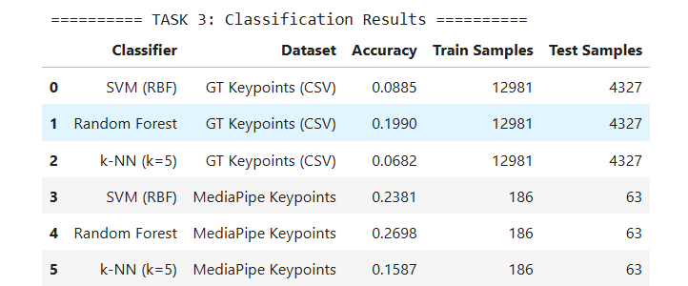

8. Conclusions
This project successfully implemented and evaluated two distinct human pose estimation pipelines and a pose classification system on the MPII dataset:
- MediaPipe (Task 1) achieved higher joint localization accuracy (PCKh@0.5) due to its deep learning backbone, but detected poses in fewer images (86%).
- Classical CV (Task 2) achieved nearly perfect detection (99%) by relying on color-based segmentation, but its geometric keypoint estimation is inherently less precise than a trained neural network.
- Pose Classification (Task 3) demonstrated that GT keypoints provide significantly better classification accuracy than predicted keypoints, highlighting the importance of the upstream estimation quality. The 53-dimensional scale-invariant feature vector captured meaningful body configuration information for activity recognition.

The complementary strengths of both approaches suggest that hybrid systems using classical methods for robust detection and deep learning for precise localization may offer the best balance in production settings.

